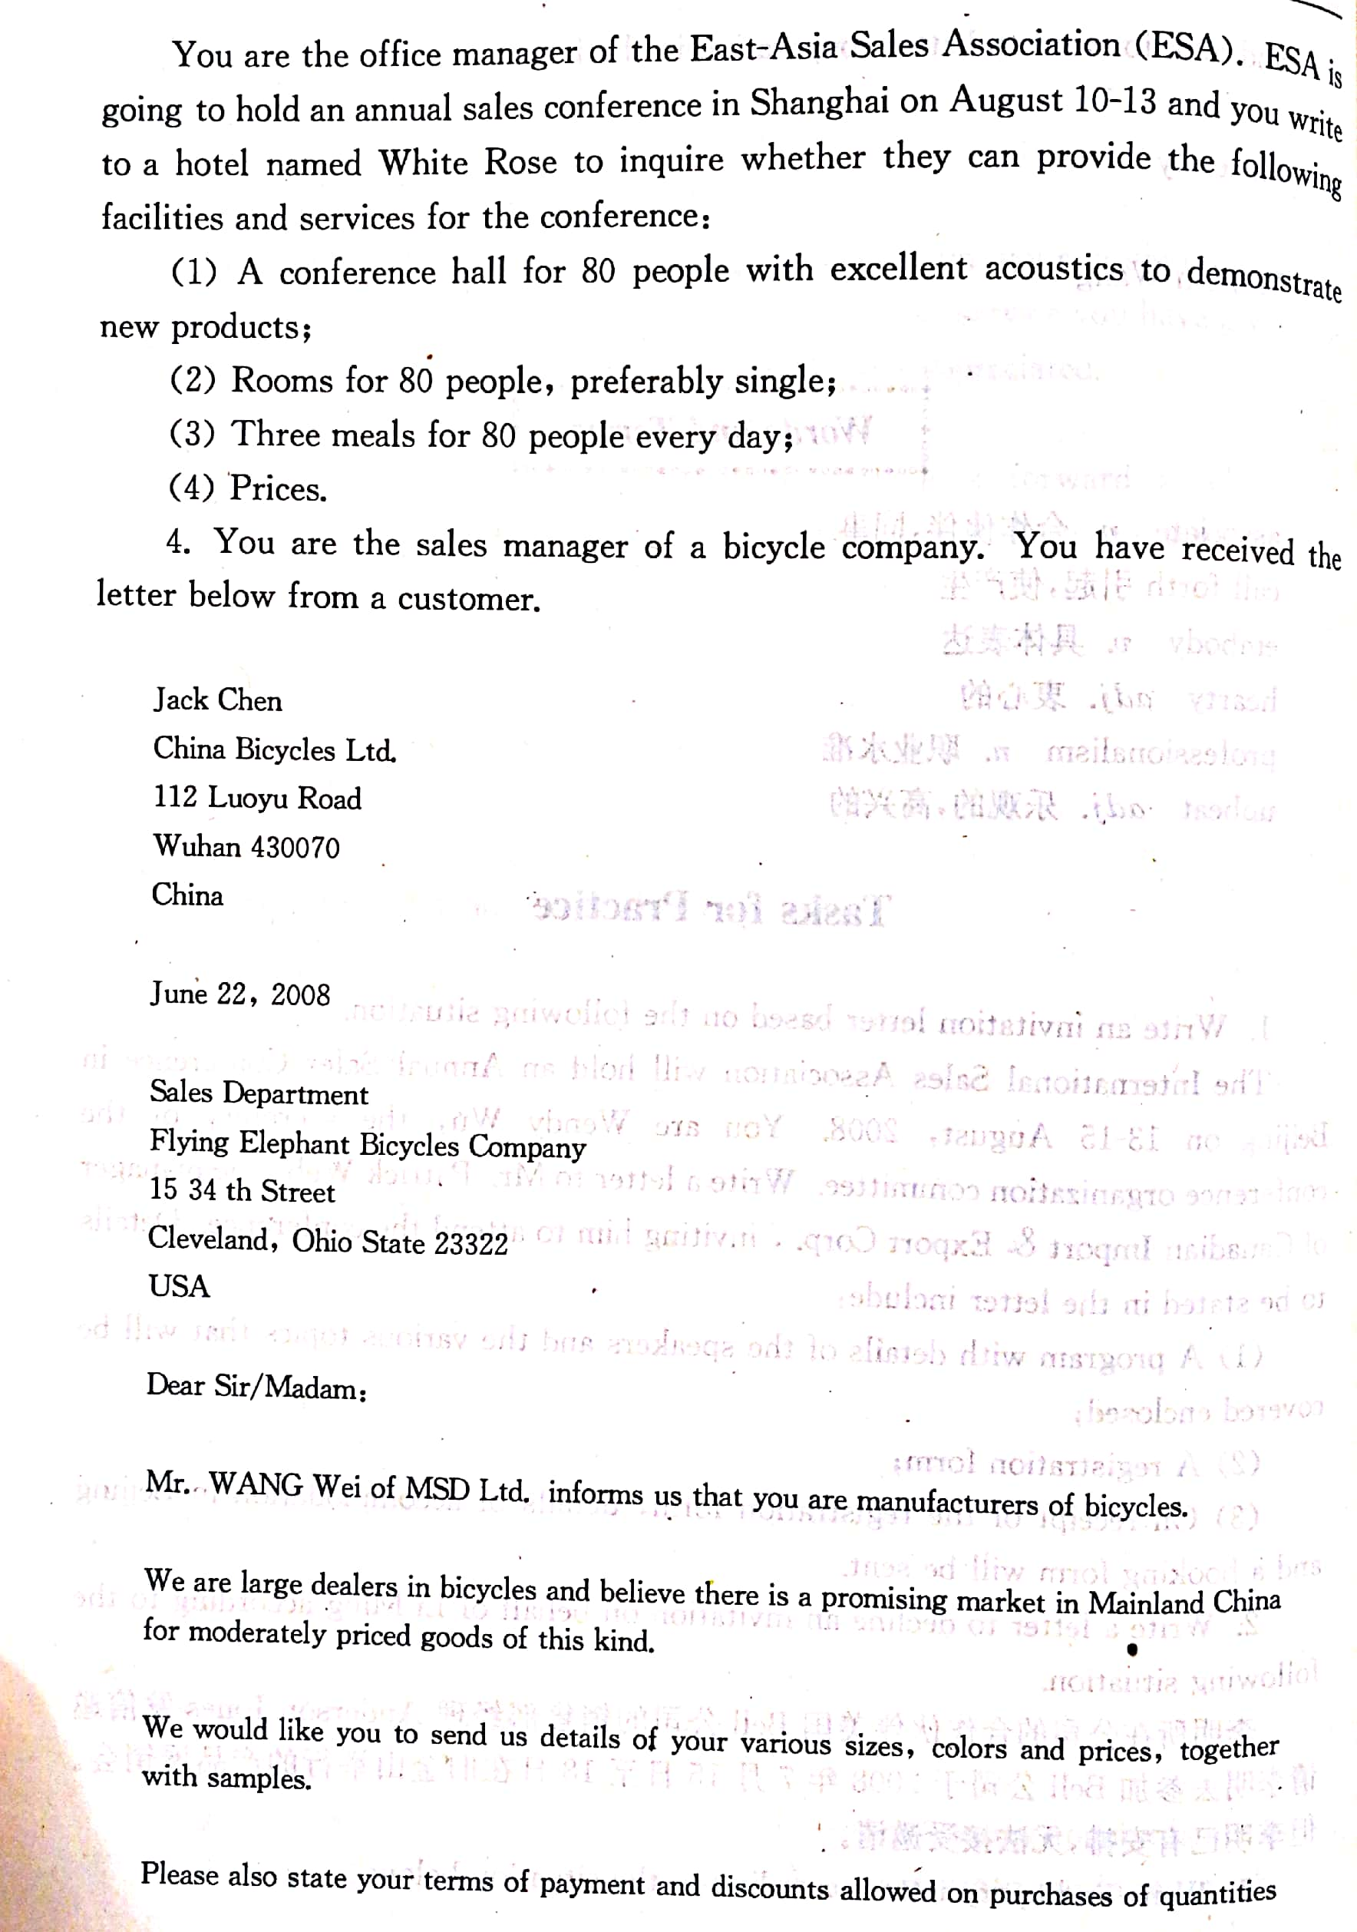

写信人地址

May 20, 2007

收信人地址

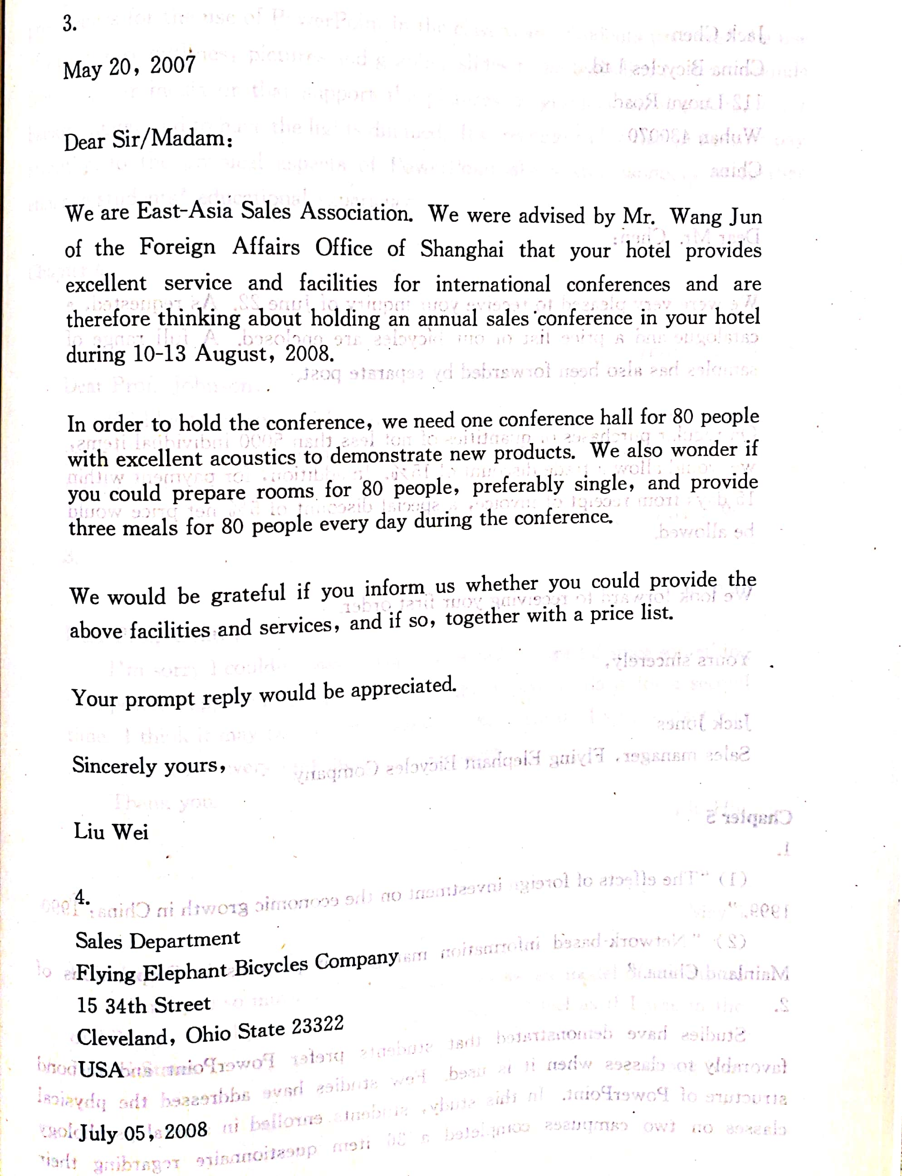

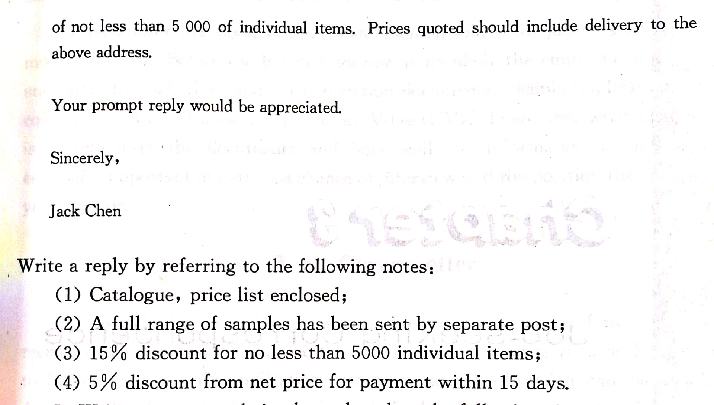
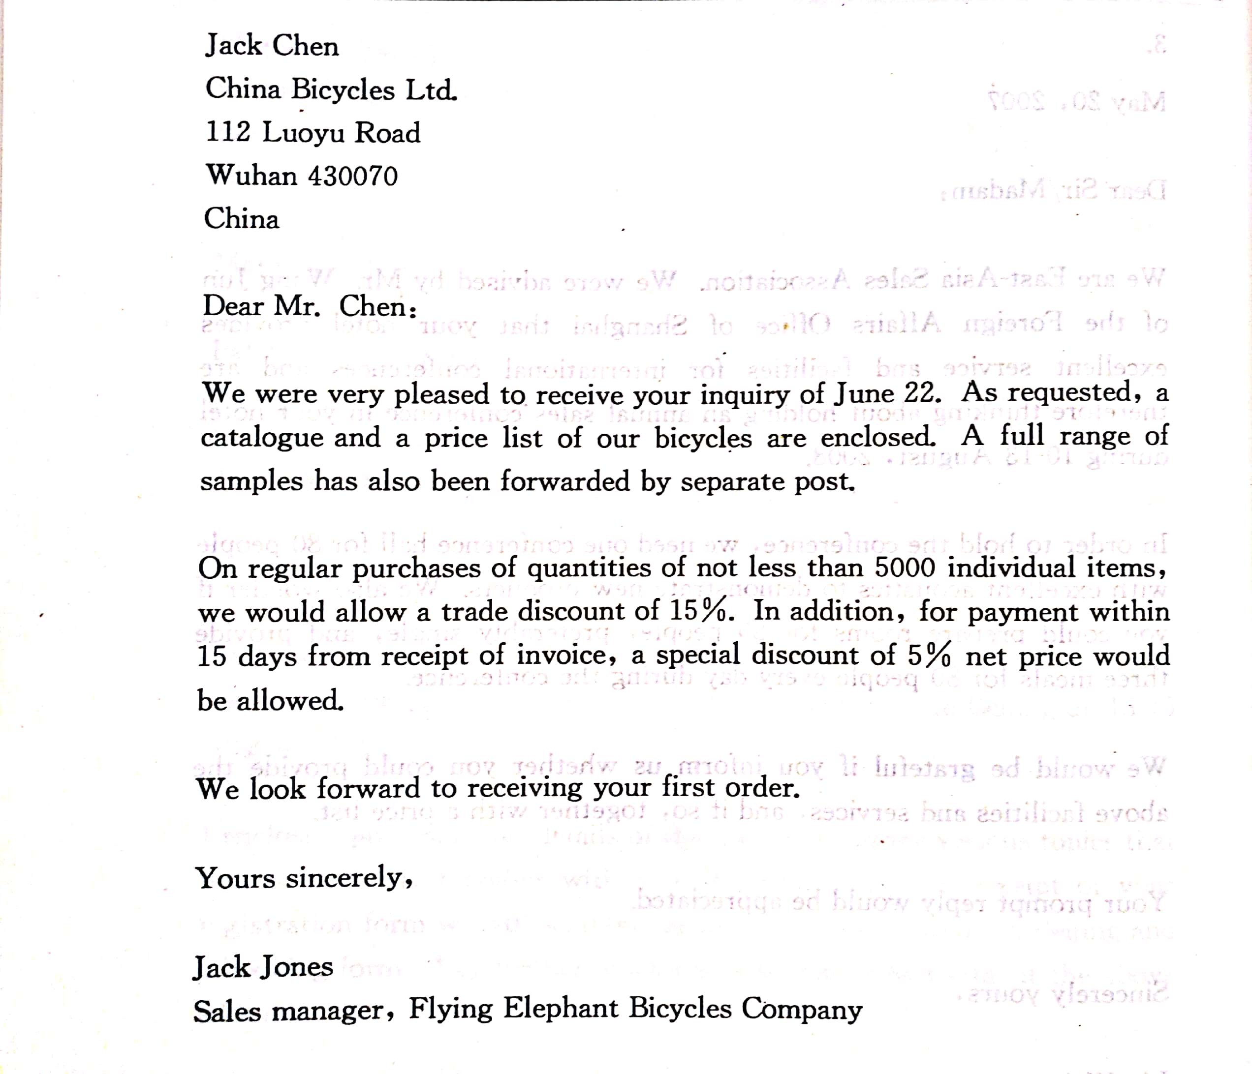

Sentence patterns to inquire:

- We would like to have more information about …
know more about…
learn about
inquire about…
receive…
- We wonder if you could…
- We would be pleased if you could send us …
inform me of…
- Could you please send us…
- I would appreciate your sending me …
it if you could send me …
- We would be grateful if you could inform us of…

